Payment Instructions for Students

Step 1: Log in to the International Student Service System of Wuhan University
Website: http://fses-admin.whu.edu.cn/ or https://whu.17gz.org/
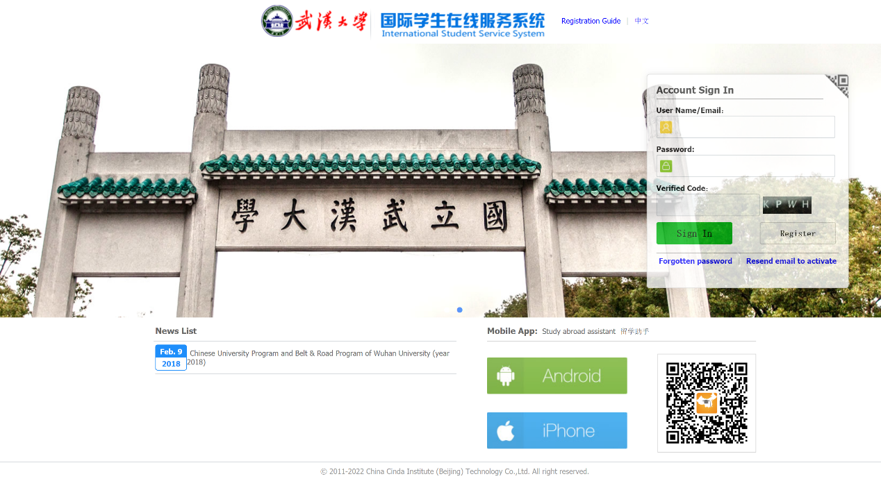
If you do not have an account, please follow the steps below to register (if you already have an account, please log in directly).
1. Click the "Register" button to create an account.
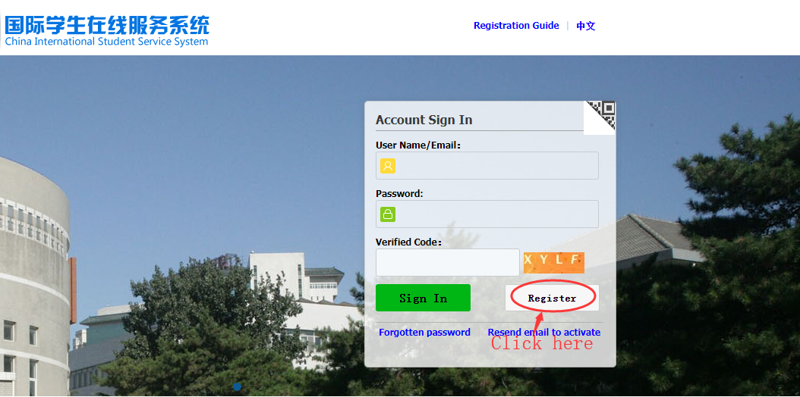
2. Enter your username, password, and email information, then click "Register".
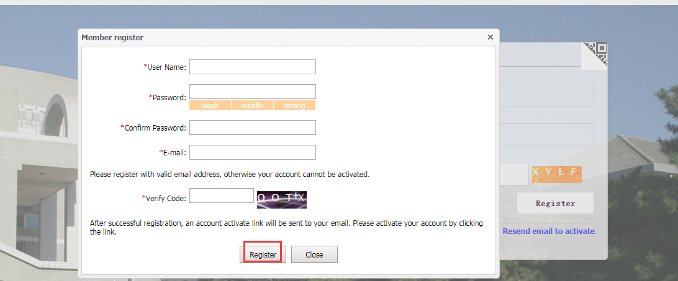
3. After registration, click "Go to Mail Box" to check the activation email.
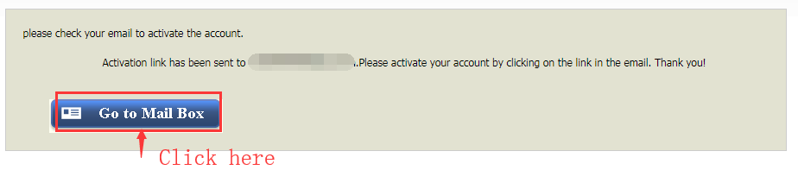
4. Click the link in the activation email to access the service system.
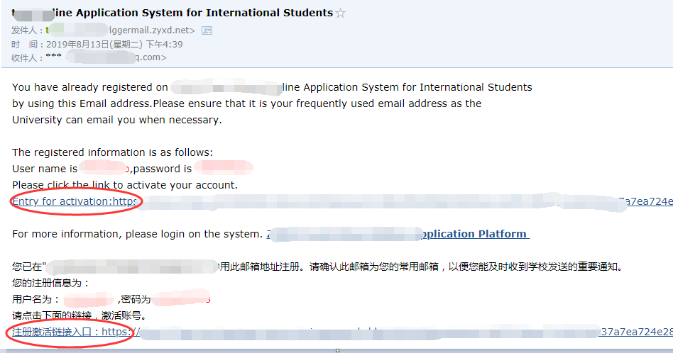
5. After getting into the service system, click "Home" to open the homepage.
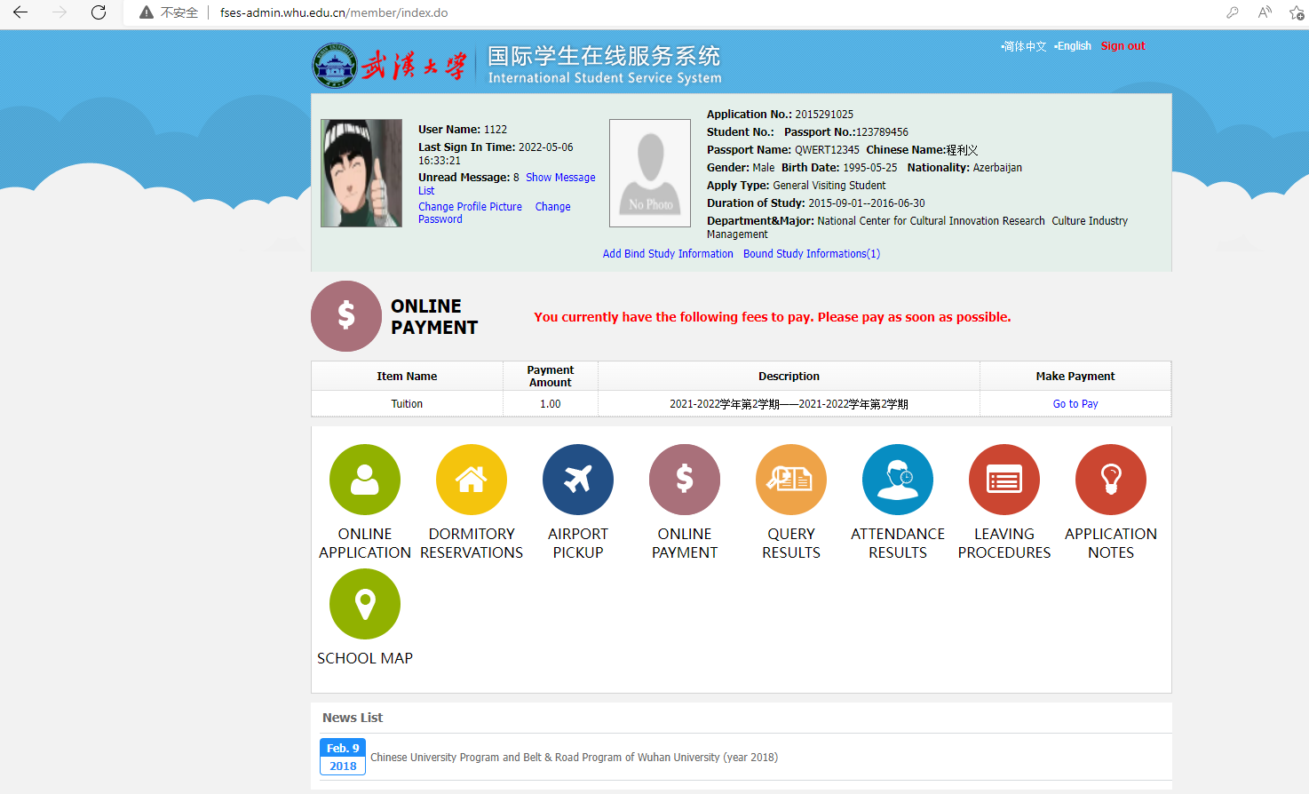

Step 2: Bind your study information
If you use the system for the first time, please click "Add Bind Study Information" to bind your personal information.
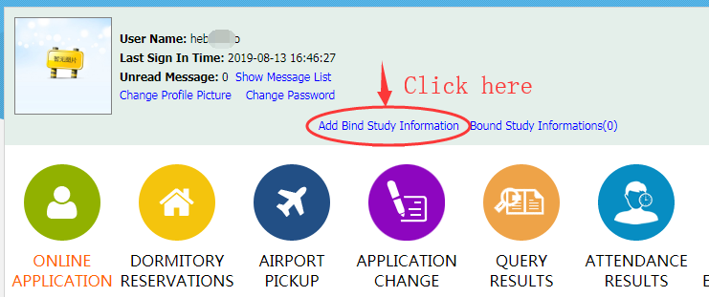
Enter your personal information, and then click "Submit".
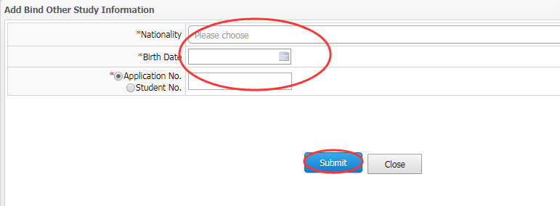
Step 3: Payment
The homepage will display a list of all fees payable, including registration fee, tuition, and accommodation fees. Click "go to pay" to pay the corresponding fees.
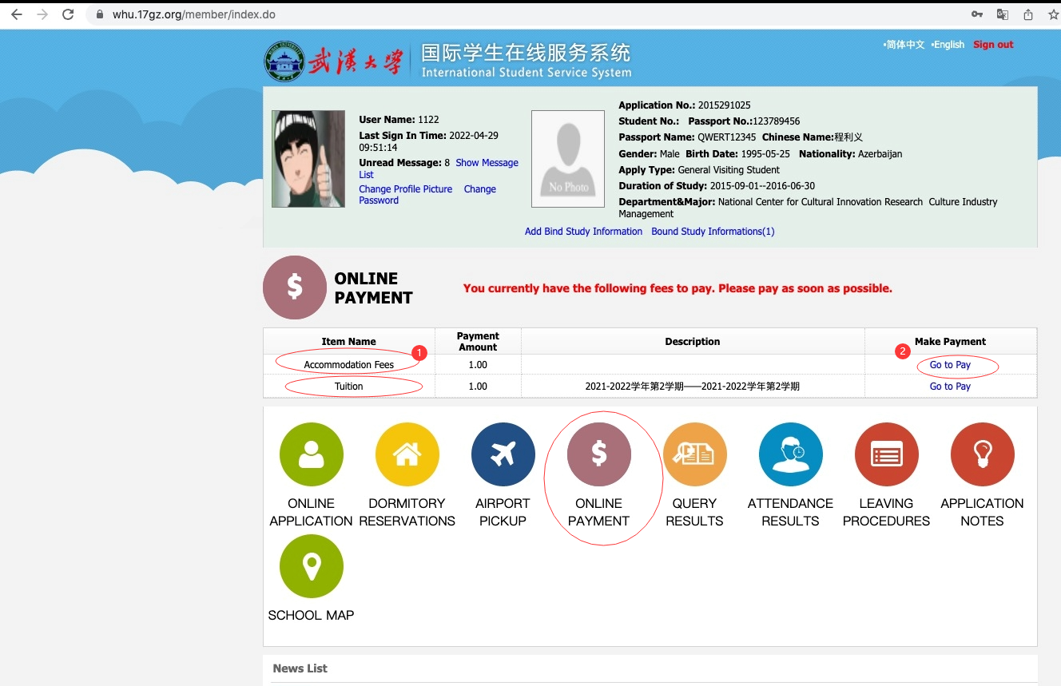
Step 4: Confirm payment information
Check your payment information for accuracy; if it is accurate, please click "check and pay".
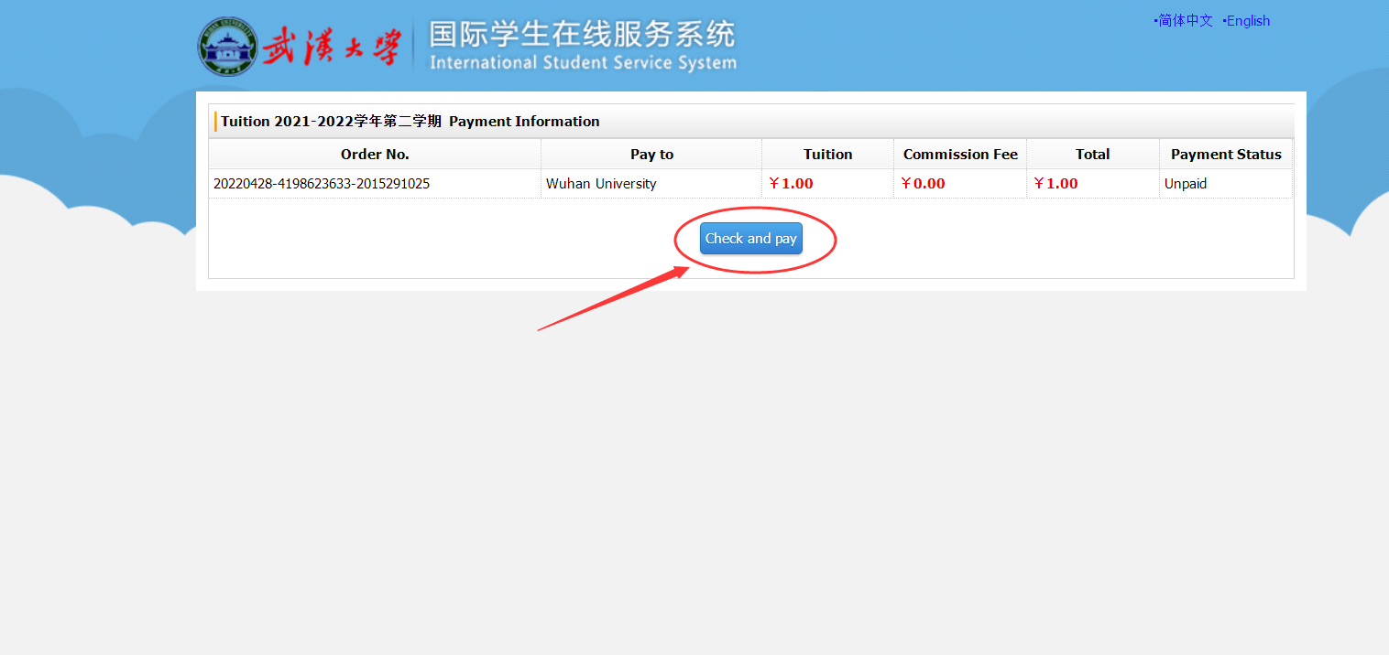
Step 5 Select payment method
Within China, you may choose WeChat Pay, Alipay, or UnionPay for payment. Outside of China, please use "master card" for payment; in this case, you are required to pay an additional service fee of about 2.5% (this fee is charged by Mastercard Inc.).

The payment interface is available in both Chinese and English. To switch languages, please click on "简体中文|English" in the upper right corner.
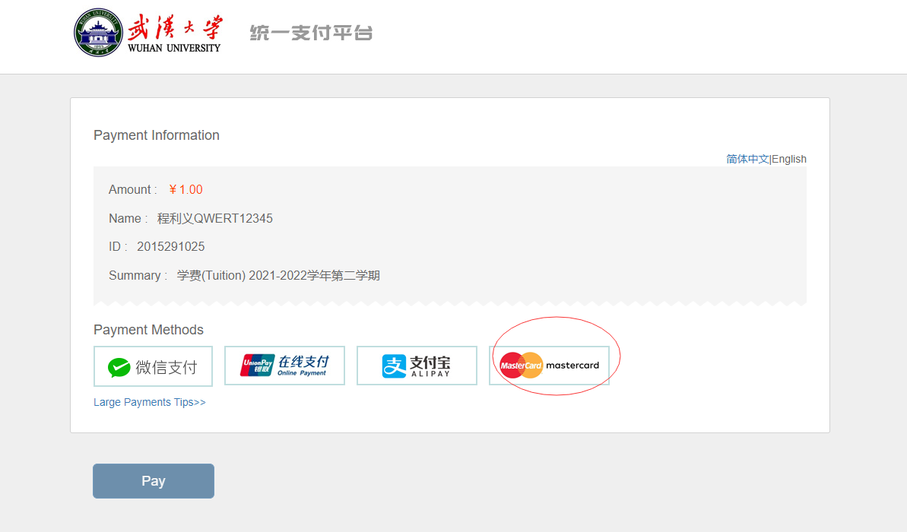
Step 6: Payment via MasterCard
If you choose MasterCard for payment, please follow the instructions on the payment interface, enter the card information and click "Pay Now" below to complete the payment.
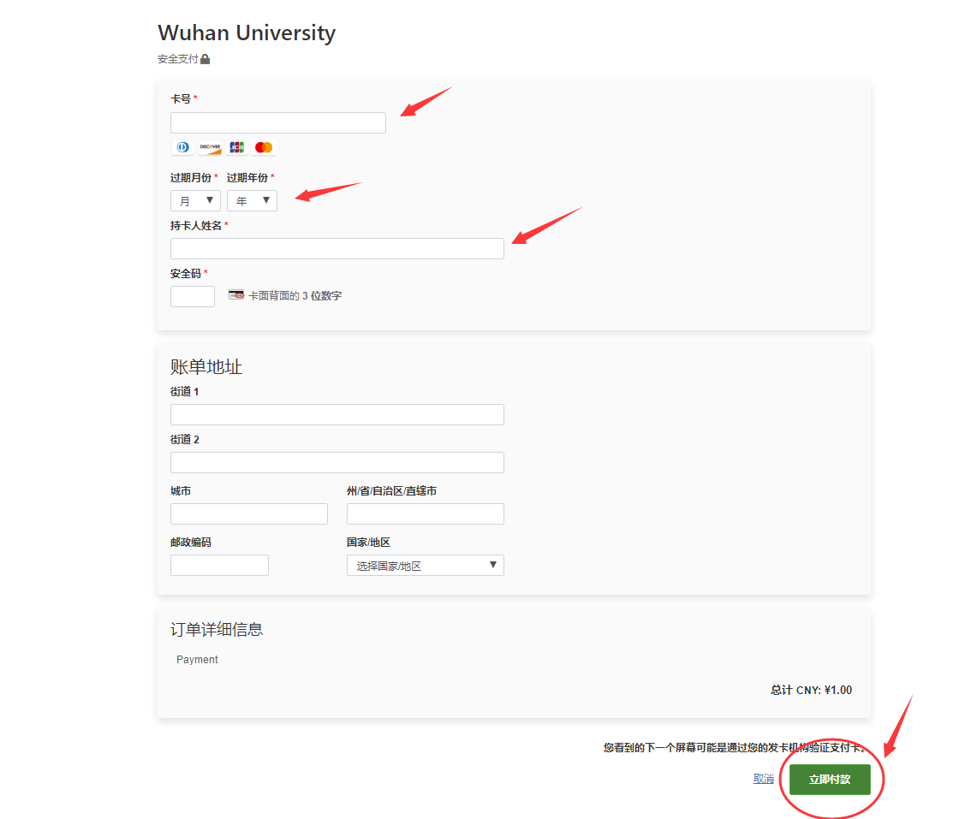
Step 7: Transaction successful
After successful payment, the system will redirect to the "payment successful" page.
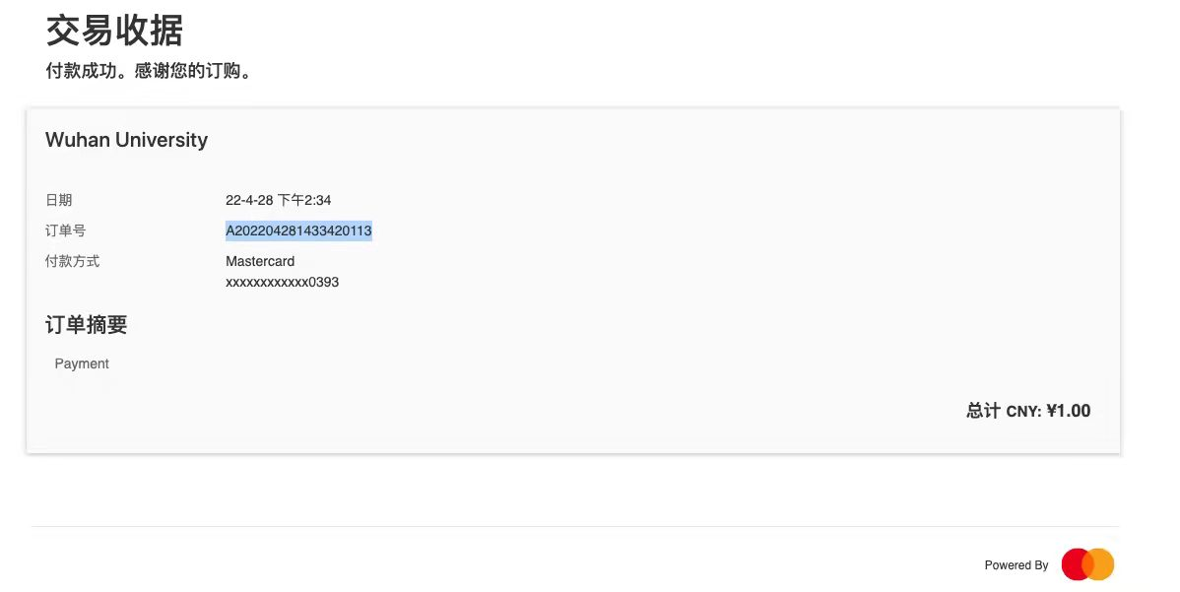

Step 8: Transaction record search
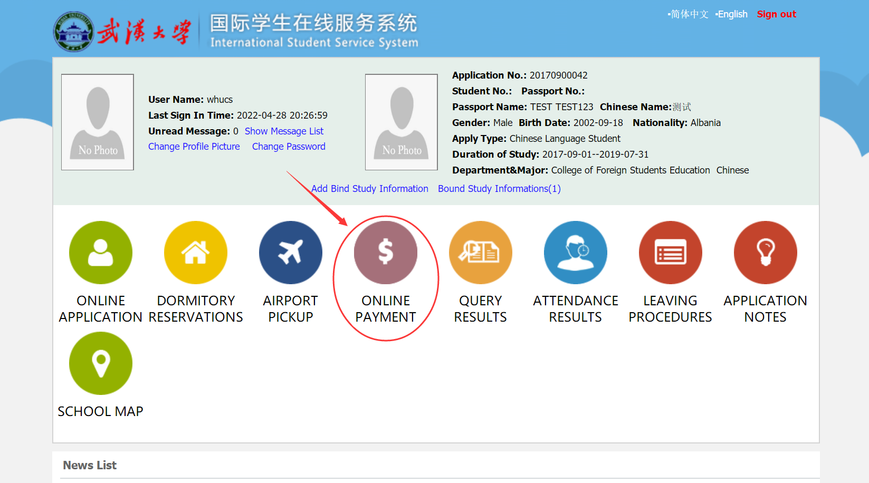
After payment, please click "ONLINE PAYMENT" on the homepage of the "International Student Service System" website to check the transaction records.

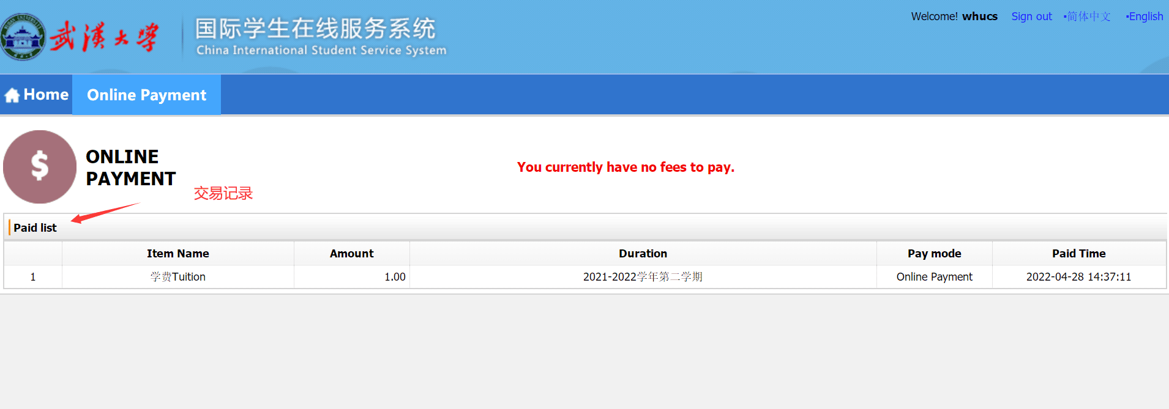
Help:
If you encounter any problems during the payment process, please contact us directly at 027-68752495.
学生支付使用说明

第一步 登录武汉大学国际学生在线服务系统
地址为:http://fses-admin.whu.edu.cn/ 或https://whu.17gz.org/
如果没有账户按如下步骤进行注册（如果已注册请直接登录）
1、点击按钮“Register”，进行帐号注册。
2、输入用户名，登录密码，邮箱信息后，点击“Register”。
3、注册完成后，点击“Go to Mail Box”，转到邮箱查收激活邮件。
4、在激活邮件里，点击链接，进入服务平台系统。
5、进入服务平台系统后，点击“Home”，进入首页。

第二步 绑定个人学习信息
如首次使用该系统，点击“Add Bind Study Infomation”,绑定个人信息。
输入个人信息后，点击“Submit”。
第三步 交费
首页会显示所有应缴纳的费用列表，包括:报名费、学费、住宿费等。点击“go to pay ”，即可缴纳对应的费用。
第四步 确认支付信息
确认支付信息无误后，请点击“check and pay”。
第五步 选择支付方式
中国境内可选择微信、支付宝、银联三种支付方式。中国境外请选择“master card”方式进行支付，您需额外支付约2.5%的综合服务费（此费用由万事达卡组织收取）。

支付界面支持中英双语，请点击右上“简体中文|English”切换语言。
第六步： 万事达通道支付
如选择万事达通道进行支付，请按支付界面提示，输入缴费卡信息，点击下方“立即付款”，完成支付。
第七步： 交易成功
付款成功后，系统会跳转到支付成功界面。

第八步：交易记录查询
支付完成后，请点击“国际学生在线服务系统”网站首页“ONLINE PAYMENT”，查看交易记录。
帮助：
如您在缴费过程中遇到问题，请直接致电027-68752495。

