How to do Wuhan University Health Punch-in?
(It's necessary for the international new students who are in China right now)
Step 1 Login Wechat and search for “武大日报平安”
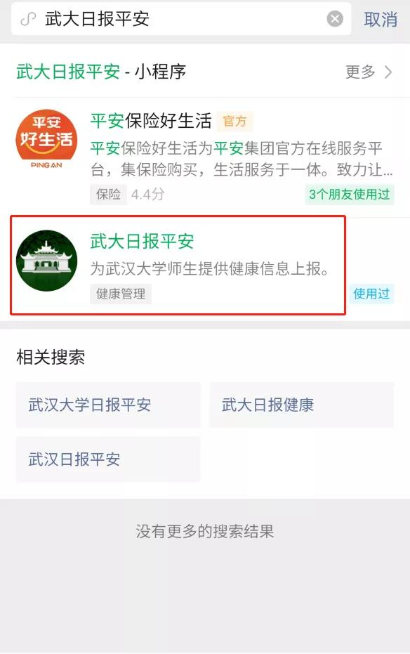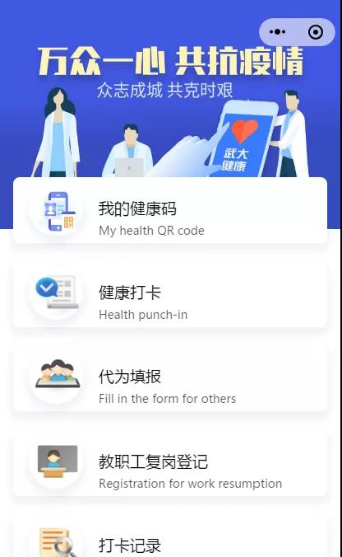
Step 2 Click “我的” and click “WHU Login” and use your ID (Your student's ID, will be received by email)and password (The first six numbers/letters of passport number)to login.

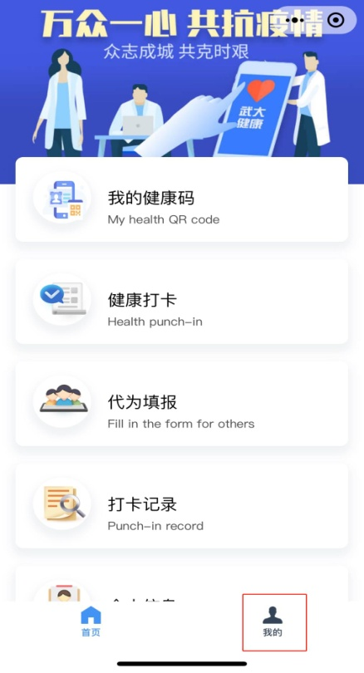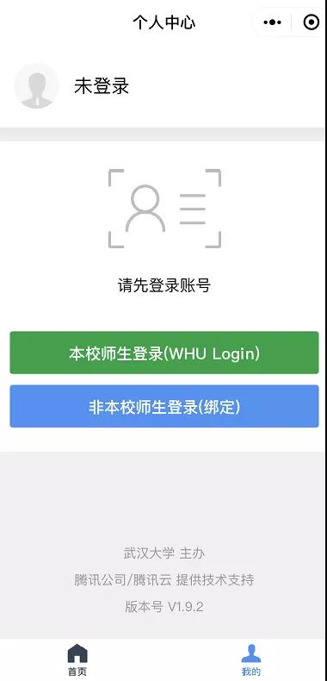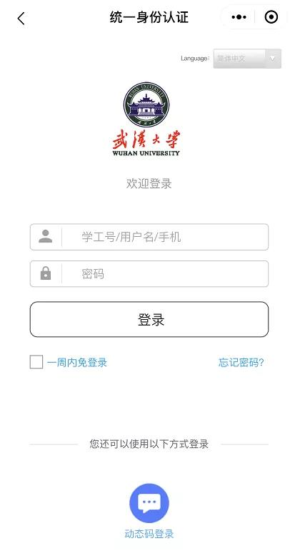

Step 3
Click “Health punch-in” and fill in your information.
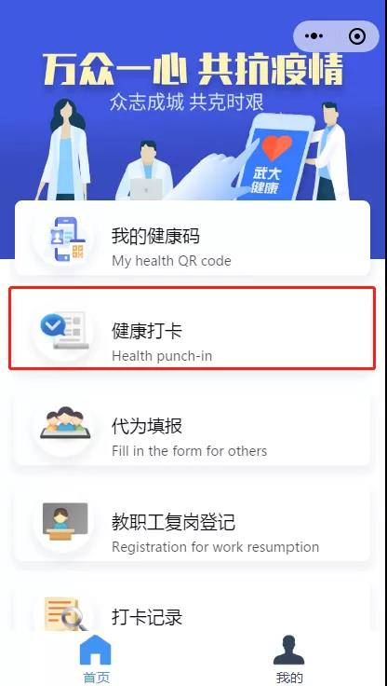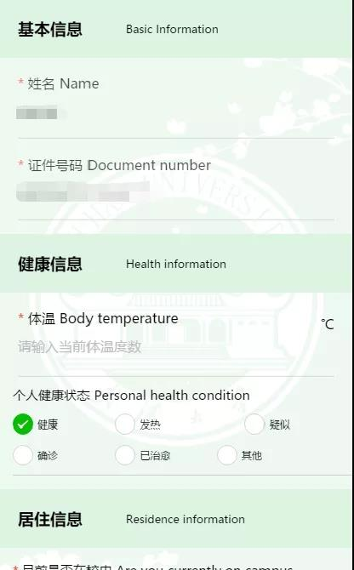
Please report your health condition carefully.
健康（Healthy）; 发热（Fever）; 疑似（Suspected）;确诊（Confirmed）;已治愈（Recovered）;其他（Other）

If you are in Hubei province, please fill in your address.
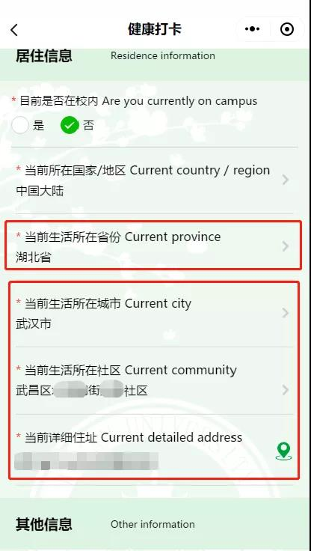
Student who are not in Hubei province can put “Wuhan University” in the detailed living address in Hubei.
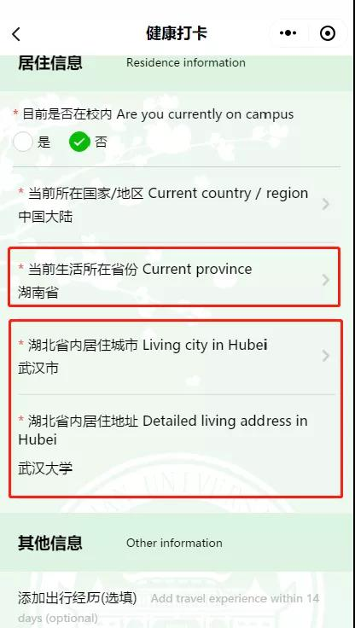
Submit your information.
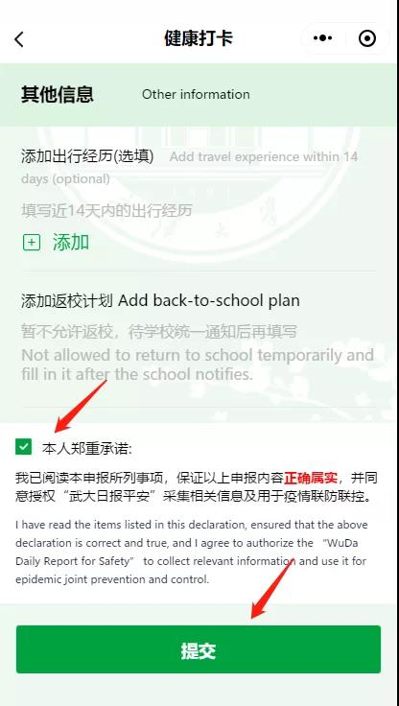

Step 4 Search for “鄂汇办” in wechat and apply for Hubei Health Code. This code is for travel in Hubei.
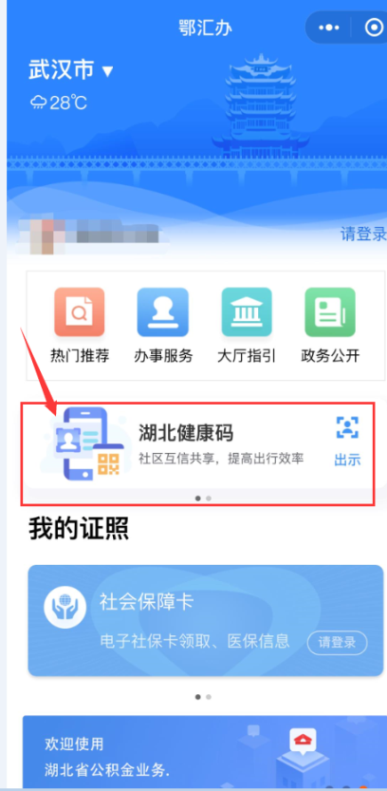

Step 5 Please do Wuhan University health punch-in everyday and make sure that you obtain at least 14 days of health punch-in record before registration.
Email us the three pictures or screenshots: 14 days Punch-in record, Nucleic acid test result and Antibody test result. You may enter campus after receiving our approval email.

Step 6 use the code to travel in the campus
When you are in Wuhan University's campus, please scan QR code at campus, report your status and submit it to get your pass.
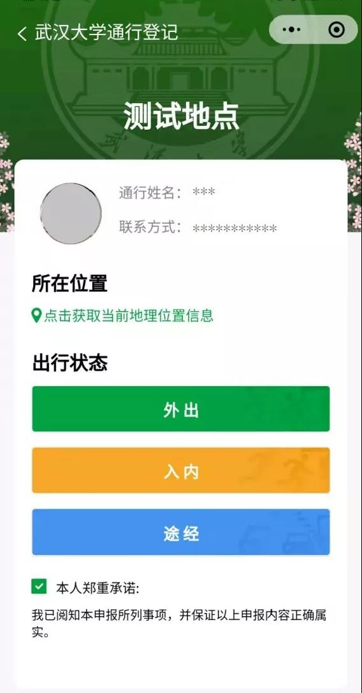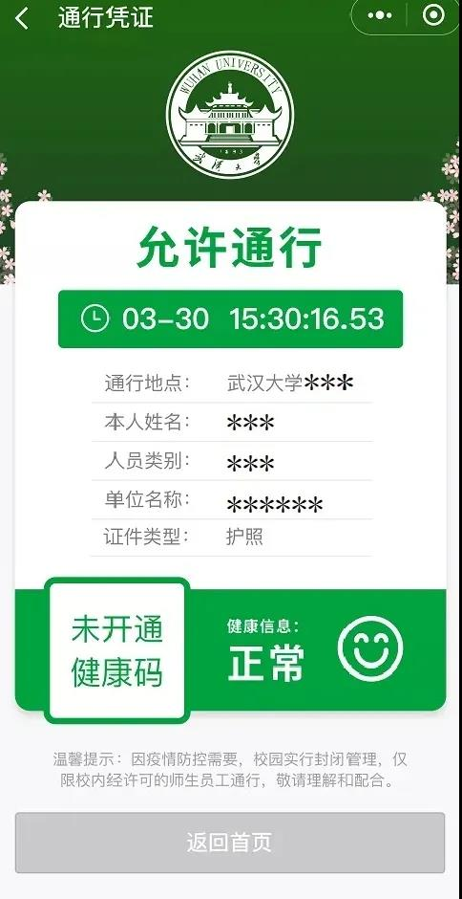
Note: If you did not finish the health punch-in as required, your will not allowed to enter.
